**These Perilous Times**

**Vol. 17, No. 12, June 21, 2025**

**“To Preach or Not to Preach”**

**(Part II)**

God’s professed people are not known as ***weekend warriors.*** We are in His regular army-always on duty. *Weekend Warrior* is a derogatory term applied *to military reservists* who train just a few weeks every year as opposed to regular military personal who are always on duty for their entire stay in the military; it is also a U.S. Army reference to the *National Guard*.

**What does this mean for us?**

**Obvious Signs Do Tell The Season**

John the Baptist, as prophesied, was the forerunner of Jesus who prepared the way for Jesus, *preaching repentance and the kingdom of God is at hand* (Matt. 3:1-3). Jesus, himself did not wait to preach and witness to others just on Sabbaths or a few weeks a year. He was on duty and about His Father’s business, beginning at a very young age (see Matt. 4:12-23; 24:14; Mark 1:14, 15; Luke 2:43-49; 4:18).

Exactly what does the word preach Mean? Preach means: “To proclaim, declare in public…to give moral or religious advice…[1] “To call out… publish, proclaim, pronounce…”[2] Proclaim, publish…” [3] As a matter of fact we are to prepare a people by announcing Jesus’ second coming, without wavering! We are to preach and declare to the world that the kingdom of heaven is at hand; not just on Sabbaths, not just when the mood strikes us-but we always need to be about our Heavenly Father’s business!

“It is recorded in the book of Acts that when the Christian Evangelist Phillip heard a certain traveler reading the Holy Scriptures, he recognized the words of the book of the prophet Isaiah and asked, ‘do you understand what you are reading? Acts 8:30. The stranger replied, ‘How can I except someone guide me’ Acts 8:31. The guidance was given as we read in Acts 30:35. ‘Then Phillip opened his mouth and began at the same Scripture, and *preached* unto him Jesus.’ By explaining the birth, Life, death, resurrection, ascension, and heavenly work of Christ as prophesied in the Old Testament and fulfilled before living witnesses, early New Testament preachers proclaimed the Gospel…” [4]

“With such an army of workers as our youth, rightly trained, might furnish, how soon the message of a crucified, risen, soon-coming Savior might be carried to the whole world! How soon might the end come-the end of suffering, sorrow, and sin! How soon, in the place of a possession here, with its blight of sin and pain, our children might receive their inheritance where the ‘righteous shall inherit the land, and dwell therein forever, ‘where the inhabitant shall not say, I am sick,’ and ‘the voice of weeping shall be no more heard.’” [5]

The word “**Go”** Means: “to move along, travel, proceed…” [6] “***Go, then, to All Peoples Everywhere*** and make them my disciples…” (Matt. 28:19 GNT Emphasis supplied). This is not a suggestion, but a declaration, from Jesus Himself! Let us finish the work-Preach the Word!

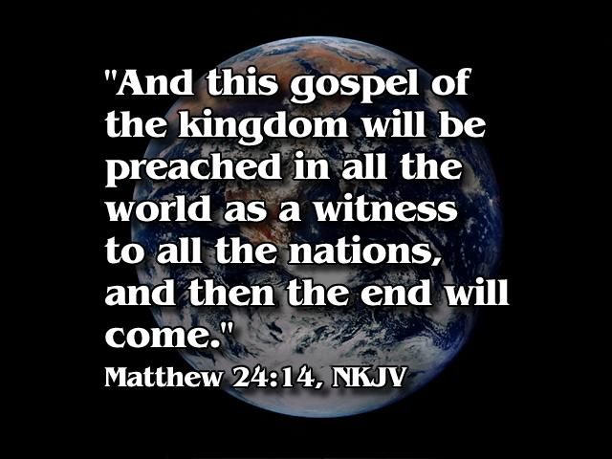

1. Webster’s New World Dictionary, (College Ed.) p. 1147.
2. Strong’s Hebrew Dictionary, Entry # 7121, p. 104.
3. Strong’s Greek Dictionary, Entry # 2784, p. 42.
4. H. M. S. Richards. What Jesus Said, Nashville, TN, Southern Publishing Assn., 1957, p. 107.
5. White. Counsels to Teachers, Parents, and Students, p. 555.
6. Webster’s New World Dictionary. p. 619.