**These Perilous Times**

**Vol. 17, No. 8, April 21, 2025**

**“Jesus’ Resurrection-Is it a Bible Mandate to Celebrate it?”**

Those who choose to celebrate the “tradition” of Easter, celebrate it on a different Sunday each year. It is usually celebrated on the first Sunday following the “Paschal” full moon-vernal (spring) equinox. The word “Paschal” stems from the word “Pascha,” the Greek and Latin word meaning “Passover” … However, nowhere in Scripture does our Lord command the keeping holy of any Sunday tradition. The Bible does mention the keeping of the “Passover Feast” for the orthodox Jews of old (See Exodus 11:1-4; 12:1-7, 18-22; Lev. Chap. 23; I Cor. 5:4-8; Rev. 5:12). However, after Christ’s death and resurrection the Jewish economy and all their feast days were nailed to the cross (See Colossians 2:6-14). Jesus is our only “Passover Lamb” (See Isa. 53:1-5; John 1:29, 35, 36; Rev. 13:8). The word “Easter” is mentioned once in the KJV of the Bible Acts 12:4. Other versions of the Bible, i.e. the New King James Version, the New American Standard Version, and the Good News Bible mention the festival (which lasted more than one day) of “Unleavened Bread” or the “Passover” (Acts 12:1-8).” After Herod killed James, he arrested Peter to please the Jewish leaders and put Peter in prison during the days of “Unleavened Bread,” and was not going to judge him until after the “Passover” festival, had ended.” Many members of the church were praying for Peter’s wellbeing, and the Lord sent an angel to the prison and set Peter free.

**What Does this mean for us?**

**Obvious Signs Do Tell The Season**

Question: Are we obligated to keep the tradition of “Easter” or the “Passover” today? Is it not good to fast and pray for ourselves and each other? God’s people should be first and foremost in communing with the “Lamb of God, who takes away the sin of the world… “John 1:29. There should be much time designated in our lives for fasting and prayer. God did give us a Holy Day to remember Him-It is called the Sabbath, not “Easter Sunday” (Gen. 2:1-3; Exodus 20:8-11). Though we may not agree with or celebrate the tradition of “Easter,” we should be ever grateful for the ***life, death, and resurrection of our Lord***, **JESUS**! “If Christ is not risen,” Paul said, “then our preaching is in vain” and “you are still in your sins!” (I Cor. 14:14, 17). “

“*Jesus Christ was physically resurrected as the God-man to heaven*, and began His crucial intercessory work as *mediator* at the right hand of God the Father (Hebrews 8:1, 2). [1] “***By Baptism we confess our faith in the death and resurrection of Jesus Christ****, and testify of our death to sin and of our purpose to walk in newness of life*…” [2] (Emphasis supplied).

**List of Works Consulted**

1. “Easter” SDA Bible Commentary, Vol. 6, pp. 50-52, 270.

2. “Easter” Andrews Bible Commentary, New Testament, p. 1500.

3. “Easter” Strong’s Greek Dictionary, entry #3957, p. 56.

4. “Easter” Webster’s New World Dictionary, (College Ed.) 1964, p. 456.

5. “Easter” The New Lexicon Webster’s Dictionary, (Encyclopedia Ed.)

1989, p. 294.

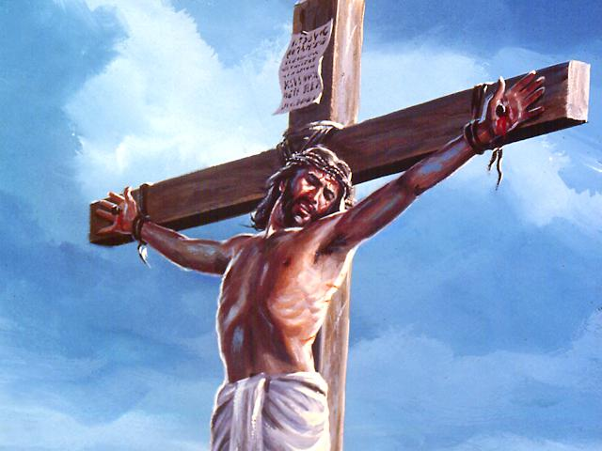

1. SDA Believe, Chapter 9, The life, Death, and Revelation of Jesus Christ, pp.121-131.
2. Ibid. Chapter 15, Baptism, pp. 217-230.