**These Perilous Times**

**Vol. 14, No. 24, Dec. 21, 2022**

**“Christ In Christmas”**

God’s “remnant people,” can clearly see the true significance of “Christmas,” and what December 25th *symbolically represents*-the birth of Christ.

**What does this mean for us?**

**Obvious Signs Do Tell The Season**

“And she shall bring forth a son, and thou shalt call His name JESUS: for HE Shall save HIS people from their sins. Matt. 1:21 KJV

And this shall be a sign unto you; ye shall find the babe wrapped in swaddling clothes, lying in a

manger.” Luke 2:12 KJV

**Counsel from God’s inspired messenger**

**(The First Advent of Christ)**

“HIS birth was without worldly grandeur. He was born in a stable, cradled in a manger; yet HIS birth was honored far above any of the sons of men. Angels from heaven informed the shepherds of the advent of JESUS, while the light and glory of GOD accompanied their testimony. The heavenly hosts touched their harps and glorified GOD. They triumphantly heralded the advent of the SON of GOD to a fallen world to accomplish the work of REDEMPTION, and by HIS death, bring peace, happiness, and EVERLASTING LIFE to man.” [1]

**More Great News!**

“For unto you is born this day in the city of David a SAVIOR, which is CHRIST the LORD.” Luke 2:11

This Christmas let’s count our blessings and thank GOD for HIS GREATEST GIFT to mankind. Born of a woman over 2000 years ago in a cattle stall, gift- wrapped in swaddling clothes (strips of cloth intended for new-born sheep to prevent blemish). Born to die for you and me, to save us from our sins!

**What Amazing Love!**

“Thanks be to GOD for HIS

unspeakable GIFT!”

II Corinthians 9:13

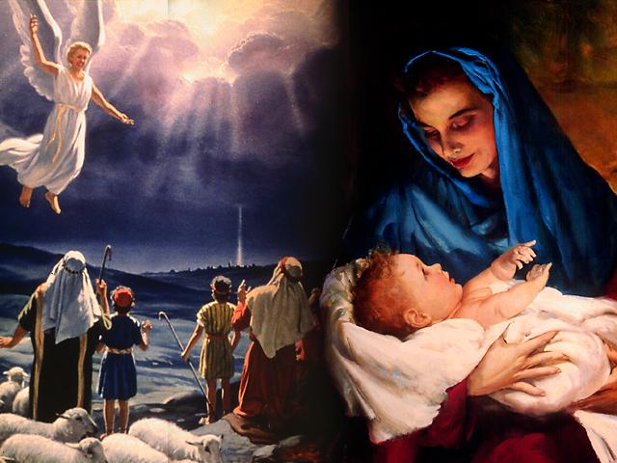

1. E. G. White. Spiritual Gifts, Vol. I, II, p. 28.