**These Perilous Times**

**Vol. 13, No. 23, Dec. 7, 2021**

**“Deciphering the Right Intel”**

Through the years, I’ve been blessed to have been able to share public evangelism meetings in different venues concerning “Bible-based,” end-time prophecies. Each night before introducing the topic to be studied, I would state my own personal mantra: “Bible Prophecy is history, written or told in in advance.” Then I would ask those in attendance the question; “What is Bible Prophecy?” To which they replied, “History, written or told in advance.”

**What does this mean for us?**

**Obvious Signs Do Tell The Season**

The infamous date of December 7 is known in the United States as “Pearl Harbor Remembrance Day.” In a previous article of TPT, some of horrific details of this tragedy were discussed that preceded the bombing of the U. S. Naval Base by the Japanese Air force, on Dec. 7, 1941, and the aftermath. There is substantial evidence on record that supports the claim that the “surprise attack,” could have been met with much more resistance, if only the “intel chatter” would have been taken seriously!

**The RHS Titanic**

On the morning of April 15, 1912, the RMS Titanic, on her maiden voyage from Southampton to New York sank in the North-Atlantic Ocean, 370 miles Southeast of Newfoundland after striking an ice berg! Several radio transmissions were sent, warning the crew of the Titanic to be watchful because treacherous icebergs were detected along its charted course. The warning stated: “Be watchful and proceed with caution.” The warning was blatantly ignored because the ship was traveling full-steam ahead trying to break a maritime, ocean-liner speed record! The rest, as it has been said, is history.

Friends, our Lord and Savior has given His people an entire Book of reliable “intel” for our admonition and safety to avoid spiritual calamities. Let’s notice a few of these warnings.

**Intel from Peter**

“*Be sober*, *be vigilant*; because your adversary the devil, as a roaring lion walketh about, seeking whom he may devour:” I Peter 5:8 (Italics supplied)

**Intel from John**

“Therefore rejoice, O heavens, and you that dwell in them! Woe to the inhabitants of the earth and the sea. *For the devil has come down to you*, *having great wrath*, because he knows that he has a short time.” Revelation 12:12 (Italics supplied)

**Intel from Paul**

“Finally, my brethren, *be strong in the Lord* and in the power of *His might*. Put on the *whole armor of God*, that you may be able to stand against the wiles of the devil.” Ephesians 6:10, 11 (Italics supplied)

**Intel from Jesus**

“Watch therefore, for you do not know what hour your Lord is coming.” Matthew 24:42

“And now I have told you before it comes, that when it does come to pass, you may believe.”  
 John 5:29

**Intel from God’s inspired messenger**

“The people of God are directed to the Scriptures as their safeguard against the influence of false teachers and the delusive power of spirits of darkness. Satan employs every possible device to prevent men from obtaining a knowledge of the Bible; for its plain utterances reveal his deceptions… When God sends to men warnings so important that they are represented as proclaimed by holy angels flying in the midst of heaven, He requires every person endowed with reasoning power to heed the message…” [1]

**More intel from John**

“Blessed is he that readeth and they that here the words of this prophecy, and keep those things that are written therein: for the time is at hand.”

Revelation 1:3

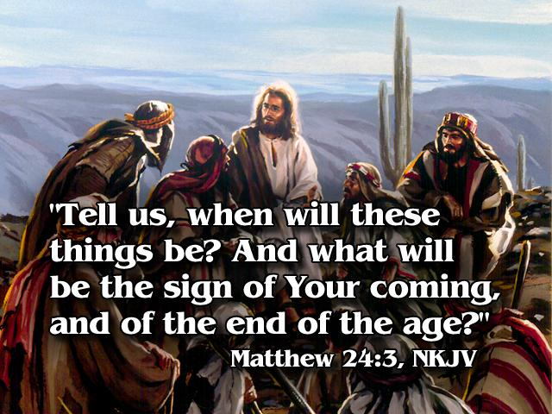

**Where does your “intel” come from?**

1. E. G. White. The Great Controversy. pp. 593. 594.