**These Perilous Times**

**Vol. 16, No. 19, Oct. 7, 2024**

**“In Tune With God’s Word”**

**(Part II)**

“Now as he sat on the Mount of Olives, the disciples came to Him privately, saying. Tell us, when shall these things be? And what will be the sign of Your coming and the end of the age? And Jesus answered and said to them: *Take heed that no man deceive you*. *For many will come in my name saying I am the Christ and will deceive many.*

Matt. 24 3-5 NKJV (Italics supplied)

“For I know this, after my departure savage wolves will come in among you, not sparing the flock***. Also, from among yourselves*** men will rise up speaking perverse things, to draw away disciples after themselves. Therefore, watch, and remember that for three years *I did not cease to warn everyone night and day with tears.*”

Acts 20:29-31 NKJV (Emphasis supplied)

**What does this mean for us?**

**Obvious Signs Do Tell The Season**

**Counsel from God’s inspired messenger**

“Again and again, Paul warned the believers against these false teachers. This peril above all others, they must guard against; for by receiving false teachers, they would open the door to errors by which the enemy would dim the spiritual perceptions and shake the confidence of those newly come to the faith of the gospel. Christ was the standard by which they were to test the doctrines/teachings presented. All that was not in harmony with His/Jesus’ teachings they were to reject… The warnings of the word of God regarding the perils surrounding the Christian church belong to us today. As in the days of the apostles some tried by *tradition and philosophy to destroy faith in the Scriptures*, so today, by the pleasing sentiments of *higher criticism, evolution, spiritualism, theosophy* (wise in divine matters) and *pantheism the enemy of righteousness is seeking to lead souls into forbidden paths…* *The work of higher criticism, in dissecting, conjecturing, reconstructing, is destroying faith in the Bible as a divine revelation*. It is robbing God’s word of power to control, uplift, and inspire human lives. *By spiritualism multitudes are taught to believe that desire is the highest law, that license is liberty, and that man is accountable to himself…*” [1] (Italics supplies).

“But there were false prophets also among the people, even as *there shall be false teachers among you*, *who privily shall bring in damnable heresies*, even denying the Lord that brought them, and bring upon themselves swift destruction. And many shall follow their pernicious ways; by reason of whom the way of truth shall be evil

spoken of.” II Tim. 2:1, 2 KJV Italics supplied)

*“None but those who have fortified the mind with the truths of the Bible* will stand through the last great crisis.” [2] “*Only those who have been diligent students of the Scri*ptures and who have received the love of the truth *(God’s Word, not the traditions of men)* will be shielded from the powerful delusion that takes the world captive.” [3] (Italics supplied).

**It’s Time to Get in Tune with GOD’s Word!**

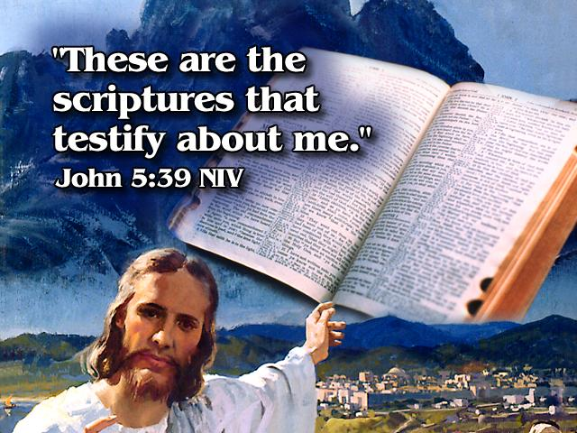

1. E. G. White The Acts of the Apostles, pp. 273-275.
2. White. The Great Controversy, pp. 593, 594.
3. Ibid,, p. 625.