**These Perilous Times**

**Vol. 14, No. 15, Aug. 7, 2022**

**“Deadly Labor Pains”**

**(Frequency of Occurrences-A Sure Sign)**

“As He sat on the Mount of Olives, the disciples came to

him privately, saying, tell us, when will these things be,

and what will be the sign of Your coming and of the

close of the age? And Jesus answered them, *See that no*

*one leads you astray*. For many will come in my name,

saying, I am the Christ, and *they will lead many astray*.

And you will hear of wars and rumors of wars. See that

you are not alarmed, *for this must* *take place*, but the

end is not yet. For nation will rise against nation, and

kingdom against kingdom, and there will be famines

and earthquakes in various places. **Verse 8**: ***All these are but the beginning*** ***of the birth pains” (ESV). “All these are the Beginning of*** ***sorrows (KJV/NKJV). “All these things are like the first pains*** ***of child birth” (TEV). All “These are the beginning of birth*** ***pains” (NIV). “But all these things are merely the beginnings of birth pangs” (NASV).*** Matthew 24:3-8 ESV

**What does this mean for us?**

**Obvious Signs Do Tell The Season**

**Counsel from God’s inspired messenger**

“***In fires, in floods, in earthquakes***, in the fury of the great deep, in calamities by sea and land, *the warning is given* that God’s Spirit will not always strive with man (see Gen. 6:3-referencing the flood to come). *Famines* will increase. *Pestilences will sweep away thousands*. Dangers are all around us from the powers without and satanic working within… I have been shown that the Spirit of the Lord is being withdrawn from the earth…

The plagues of God are already falling upon the earth sweeping away the most costly structures as if by a breath of fire from heaven… *God has a purpose for allowing these calamities to occur*. They are one of His means *of calling men and women to their senses*. By unusual workings through nature God will express to doubting human agencies that which he clearly reveals in His Word. ***How frequently*** we hear of earthquakes and tornadoes, of destruction by ***fire and flood***, with great loss of life and property! …they are among the agencies by which He (God) seeks to arose men and women to a sense of their danger.” [1]

Kentucky 2022 Ellicott City, Maryland 2018

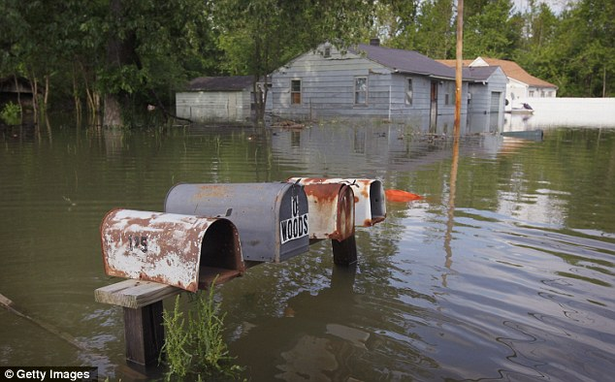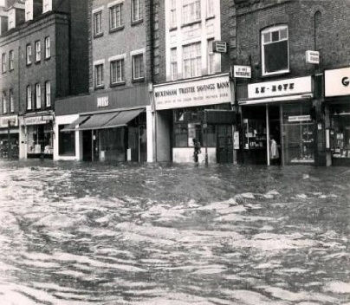

California Fire 2022 France Fire 2022

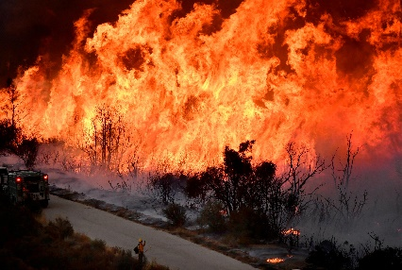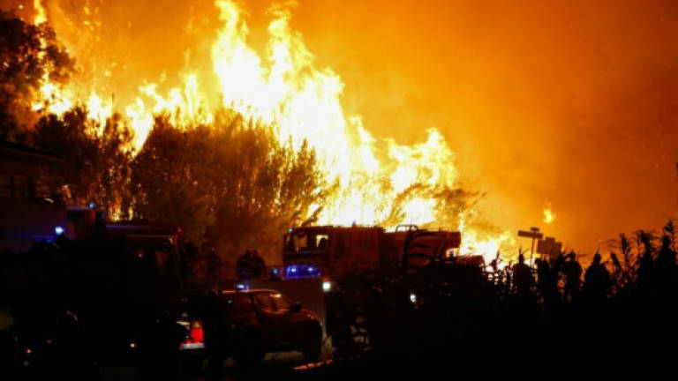

Philippines’ 7. 0 Earthquake July, 2022

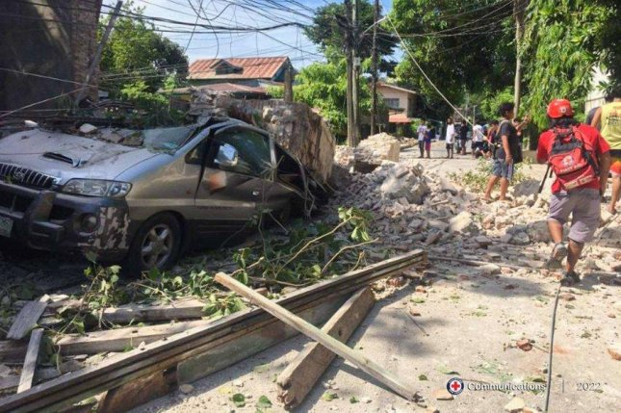

“And do this, knowing the time, *that now it is high time to awake out of sleep*; for now, our salvation is nearer than when we first believed. The night is far spent, the day is at hand. Therefore, let us cast off the works of darkness, and let us put on the armor of light.”

Romans 13:11,12 NKJV

**Counsel from God’s inspired messenger**

**“**The Storm is coming, the storm that will try every man’s faith of what sort it is. Believers must now be *firmly rooted in Christ* or else they will be led astray by some phase of error.”

“Now learn a parable from the fig tree: when its branch has already become tender and puts forth leaves, you know that summer is near*. So, you also when you see all these things, know that it is near – at the doors*. Matthew 24: 32, 33 NKJV



1. E. G. White. Last Day Events, pp. 23-28