Thede Perilous Times
Vol. 16, No. 14, July 21, 2024

Introduction to Revelation
Part XIII
Revelation and Sunday Sacredness

“Since Revelation is a book of the last days, and since it centers on Jesus, one would expect to find some verses in the book in regard to the church custom of keeping Sunday as a holy day in honor of His resurrection.” Throughout the New Testament the first day of the week is mentioned only eight times, but none of them make a single reference to it as being a holy day, or a change of God’s Holy Sabbath, created by God in Gen. 2:1-3.” Daniel states that the “Little Horn” power, Pagan Rome transitioning to Papal Rome will be blasphemous toward God, persecute God’s people and think to change times and laws (see Dan. 7:8-25; Rev. 13:1-18; SDA Believe, “The Sabbath,” Chapter 20, pp. 287-306).

What Does this mean for us?

A. Bible Texts Alluding to the First Day of Week (Sunday):
1. Matt. 28:1; Mark 16:1, 2; 16:9; Luke 24:1, 2; John 20:1; 20:19; I Cor. 16:1-3. Some of these Sunday texts (first day of the week) reference Christ’s Resurrection. But not one of them implies that the Seventh-day Sabbath was changed to first day of the week and is to be kept holy.

Obvious Signs Do Tell The Season

B. Comments from Christian Churches Regarding the Sabbath Commandment:
1. Baptist Church- “There was and is a commandment to keep holy the Sabbath day, but that Sabbath was not Sunday…”
2. Catholic Church- “You may read the Bible from Genesis to Revelation, and you will not find a single line authorizing the sanctification of Sunday…”
3. Episcopal Church- “Is there any command in the New Testament to change the day of weekly rest from Saturday to Sunday? None… “
Jesus states very plainly in the fourth commandment (Ex. 20:8-11) Remember the Sabbath day (not Sunday) to keep it holy… He also states in Isaiah 66:22, 23 in the new earth from one new moon until the next all will worship Him on the Sabbath, not Sunday.

Ezekiel states that God’s Sabbaths are a sign between Him and His people.

“Moreover, I gave the My Sabbaths, to be a sign between them and Me, that they might know that I am the Lord that sanctifies them.” Ezek. 20:12 NKJV (see also Verse 20)

“And He said to them, the Sabbath was made for man, and not man for the Sabbath. Therefore, the Son of man is also Lord of the Sabbath.” Mark 2:27, 28 NKJV

No where throughout the entire Bible does it suggest that the first day of the week (Sunday) is the “Lord’s Day” or to be kept holy. According to the Sabbath commandment (Ex. 20:8-11) Sunday is just one of the typical six working days (see Ex. 20:9).
“If you love me keep My Commandments.” John 14:15 NKJV

“For assuredly, I say to you, till heaven and earth pass away, one jot or one tittle will by no means pass from the law till all is fulfilled.” Matt. 5:18

“Jot: Gr. Iota the ninth letter of the Greek alphabet, corresponding to the Hebrew yod the smallest letter in the Heb. Alphabet.”
“Tittle: Gr. Keraia literally a ‘little horn,’ probably to be identified with the little hook on the letter wau or a small part of some other letter needed to distinguish it from one similar to it.” To put in in today’s vernacular, not one dotting of an “I” or the crossing of a “T” from the law will be removed or changed!

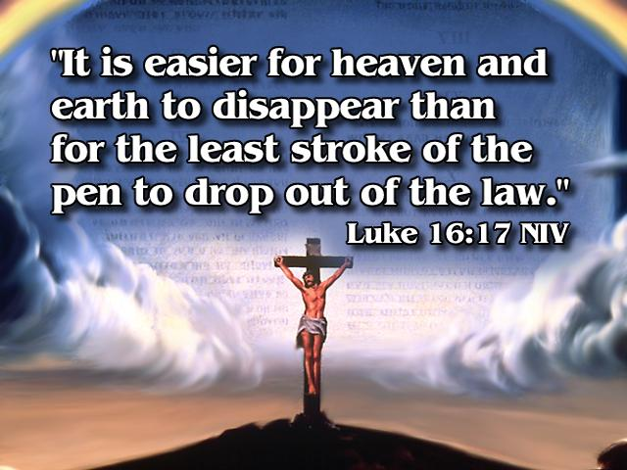

Jesus is our example-not the traditions of men!

“So, He came to Nazareth, where He had been brought up. And as His custom was, He went into the synagogue on the Sabbath day, and stood up to read.” Luke 4:16 NKJV

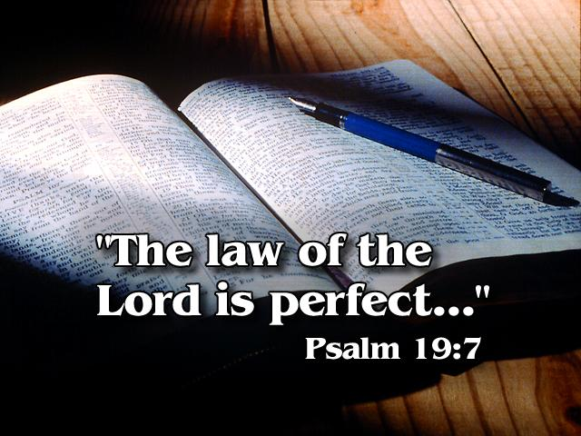

THE DEFENSE RESTS!

Revelation Seminars, Lesson # 11, Seminars Unlimited, PO Box 66, Keene, TX, 76059.
Paper by Eward T. Hiscox, Author of Baptist Manual.
James Cardinal Gibbons, The Faith of Our Fathers, p. 111.
Manual of Christian Doctrine, p. 127.
SDA Bible Commentary, Vol. 5, p. 332.
Ibid., p. 332

