**These Perilous Times**

**Vol. 15, No. 7, April 7, 2023**

**“The Resurrection and The Life”**

**Question:** What doJelly beans, chocolate bunny rabbits, yellow marshmallow chicks, the coloring of hard-boiled eggs, “easter baskets,” and “easter bonnets” have to do with the resurrection of Jesus? Absolutely nothing! It’s part of tradition and the corporate business worlds way to *rake in the dough* at the expense of vulnerable consumers.

**What does this mean for us?**

**Obvious Signs Do Tell The Season**

**A little history lesson**

Easter: “A mistranslation in Acts 12:4. A translation of the Hebrew *Pesach,* “the Passover.” *Pascha* is elsewhere in the NT translated “Passover” (Matt. 26:2 etc.). The word “Easter” is never used of the Jewish Passover. It’s of Anglo-Saxon origin, from the Anglo-Saxon *Eostre, the goddess of spring,* in whose honor a festival was celebrated at the time of the *vernal equinox.*” [1]

Easter: Gr. *Pascha*, “Passover.” The translation “Easter” is an unfortunate one…The whole paschal feast is meant, and not merely a single day of it… The word “Easter” is of Anglo-Saxon origin, derived from the Norse *Eostre*, the goddess of spring, in whose honor a festival was celebrated each year at the time of the vernal equinox. The term “Easter” now properly describes only the Christian festival that took the place of the Passover day. It appears in Christian history in the 2nd century and was celebrated as the festival of the resurrection. The *Roman bishops* urged that its celebration fall always on a Sunday. (Eusebius *Ecclesiastical History* v*.* 23-25), a custom that doubtless contributed to the practice of Sunday observance…” [2]

Easter: “the name of a pagan vernal festival almost coincident in date with the *paschal festival* of the church, an annual Christian festival celebrating the Resurrection of Jesus, held on the first Sunday, after the date of the first full moon that comes after March 31.” [3]

Easter: “The chief Christian festival, which celebrates the Resurrection of Christ, on the first Sunday, after the first full moon, that coincides with, or comes after the spring equinox (taken as March 31) *Eastre* *goddess of dawn* whose festival was celebrated at the spring equinox.” [4]

**Good News-Jesus’ words to Martha**

Jesus said unto her**, “I am the resurrection and the life: he that believeth in Me, though he were dead, yet shall he live.”** John 11:25 KJV

Jesus told His disciples in advance that He would be betrayed and crucified and *rise from the dead* on the third day (See also John 14:29).

**“Behold we go to Jerusalem; and the Son of man shall be betrayed unto the chief priests and unto the scribes, and they shall condemn him to death, and shall deliver him to the Gentiles to mock, and to scourge, and to crucify Him: and the third day *He will rise again.*”** Matt. 20:18, 19 KJV

“In Christ’s life of perfect obedience to God’s will, His suffering, death, and resurrection, God provided the only means of atonement for human sin, so that those who by faith accept this atonement may have eternal life, and the whole creation may better understand the infinite and holy love of the Creator. This perfect atonement vindicates the righteousness of God’s law and the graciousness of His character; for it both condemns our sin and provides for our forgiveness… “If Christ is not risen, Paul said, then our preaching is in vain, and your faith is also vain, and you are still in your sins!” (I Cor. 15:14, 17). Jesus was physically resurrected (Luke 24:36-43) ascended as the God-man to heaven, and began His crucial intercessory work as mediator at the right hand of God the Father (Heb. 8:1,2).” [5]

Praise God for the resurrection of Jesus. Without His death and resurrection there would be no hope for humanity.

**Please take some time to meditate on**

**John 3:16; 10:11, 15**

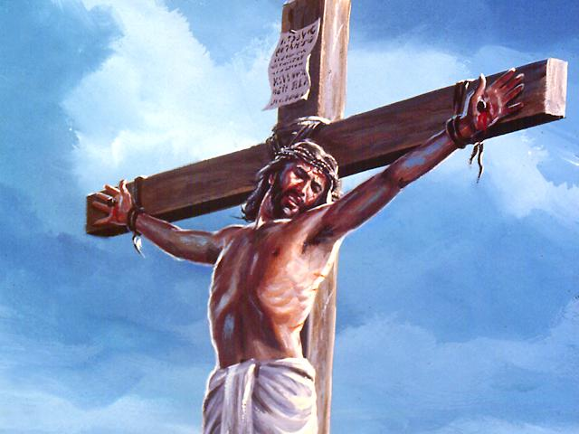

1. SDA Bible Dictionary, Vol. 8, pp. 298, 299.
2. SDA Bible Commentary, Vol. 6, p. 279.
3. Webster’s New World Dictionary (College Ed.) Cleveland & New York, World

   Publishing Co., 1964, p. 456.
4. The New Lexicon Webster’s Dictionary (Encyclopedia Ed.) New York, Lexicon

   Publishers, 1989., p. 295.
5. Seventh-day Adventists Believe, “An Exposition of Fundamental Beliefs,” Chapter

   9, pp. 121-133.