**These Perilous Times**

**Vol. 14, No. 7 April 7, 2022**

**“Signs of the Times”**

**Part II**

**Historical events that occurred on April 7**

In A.D. 529, the first draft of the “Corpus Juris Civilis,” (A fundamental work in jurisprudence-the philosophy/science of law) is issued by Eastern Roman Emperor Justian I.

In 1724 Johann Sebastian Bach’s Premiere Performance of “St. John’s Passion,” BWV 245 (work/ composition No.) was performed at Nicholas Church in Leipzig.

In 1933 Prohibition is repealed for beer of no more than 3.2% of alcohol by weight, eight months before the ratification of the XXI Amendment of the Constitution.

In 1940 Booker T. Washington, was the first African American featured on a U.S. Postage Stamp.

In 1948 The World Health Organization is established by the United Nations.

In 1969 the Internet celebrates its “symbolic birth date,” with the publication of RFC 1.

In 1978 the development of the *“neutron bomb,” (*A weapon of mass destruction) is cancelled by President Jimmy Carter.

In 1964 Rwandan genocide began with the *massacre* of Tutsis in Kigali Rwanda.

In 1995 the First Chechen War began when Russian paramilitary troops began *massacring* civilians in

Sanashki Chechnya, (Sound familiar)?

Solomon stated: “…there is no new thing under the sun,” (Ecclesiastes 1:9).

**What does this mean for us?**

**Obvious Signs Do Tell The Season**

There will always be laws. There will always be law-breakers There will always be music. There will always be warmongers. There will always be peace makers. There will always be racists. There will always be social media. There will always be drugs. There will always be health studies, as long as *this current world exists*-*but what about tomorrow?*

**No one knows what a day may bring**

We are all aware of what’s been happening right now in the country of Ukraine. The Russian dictator, Vladmir Putin and his military forces are massacring hundreds of innocent men, women, and children!

**Question:**

What is the role of God’s **“remnant”** people in the midst of all the mayhem that is now wreaking havoc *world-wide*?

**Answer:**

Thy word is a lamp unto my feet, and a light unto my path” Psalm 119:105

God’s Word, as stated many times before has all the answers to our perplexing questions? The Bible is God’s ***“How-to Manual”*** for Christians. The Bible is His people’s “***principal”*** text book for “Divine Guidance.”

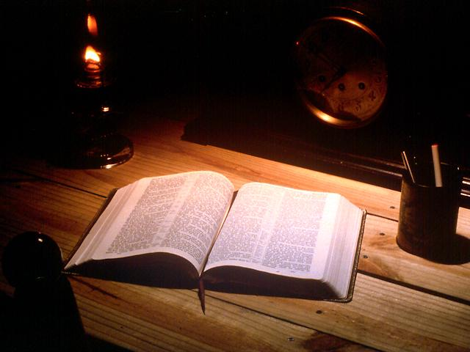

As we engage in the study God’s Word, we will receive the wisdom needed to deal with any, and all situations we are confronted with. However, we are admonished not to put off until tomorrow what can be accomplished today (See Matt. 6:34; James 4:13-15).

Today, is the day of Salvation (II Cor. 6:1, 2). Today, all people need to hear the good news about Jesus. Today, all people need relief from their illnesses and oppressors. Today, we all need to engage in Christ’s ministry for lost souls, (See Matt. 25:31-45).

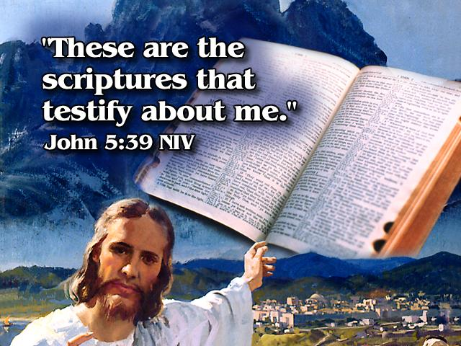

**Time to tell it to every kindred and nation!**