**These Perilous Times**

**Vol. 15, No. 24, Dec. 21, 2023**

**“Born to Die That We May Live”**

Though many traditional holidays can be a good thing, the custom of celebrating Christ’s birth**, God’s gift to mankind is a blessed thing!** **Jesus Immanuel-God with us** (See Isa. 7:14; Matt. 1:18-23) **is truly divine!** **Born to die for our Salvation!**

This is the stone which was rejected by you builders, which has become the chief cornerstone. ***Nor is their salvation in any other name under heaven given among men by which we must be saved***.” Acts 4:11, 12 NKJV (Emphasis supplied)

“And behold, there was a man in Jerusalem whose name was Simeon, and this man was just and devout, waiting for the Consolation of Israel, and the Holy Spirit was upon him. And it had been revealed to him by the Holy Spirit that he would not see death before he had seen the Lord’s Christ. So, he came by the Spirit into the temple. And when the parents brought in the Christ Jesus to do for Him according to the custom of the law, he took Him up in his arms and blessed God and said: Lord. Now You are letting Your servant depart in peace. According to ***Your word***; for my eyes have seen ***Your Salvation***.”

Luke 2:25-31 NKJV (Emphasis supplied)

**What does this mean for us?**

**Obvious Signs Do Tell The Season**

Please do not let the **“world’s traditional view”** of December 25th distract you. Our focus should be on **Christ’s birth**, and his significance to the Salvation of mankind, not on Santa Claus. Getting caught up in commercialism leads to over spending, and buying needless gifts that are often returned which leads to stress, not Salvation! Let me restate the decades old cliché: **“JESUS is the reason for the season.”** *However,* ***meeting the needs*** *of others is exactly what* ***Christ did*,** and we are admonished to follow **HIS** example **(See Matt. 25:34-40)!**

**Counsel from God’s Inspired messenger**

“*I saw that our holidays should not be spent in patterning after the world, yet they should not be passed by unnoticed, for this will bring dissatisfaction to our children*. On these days when there is danger that our children will be exposed to evil influences, (selfishness and greed) and become corrupted by the pleasures and excitement of the world, let the parents study to get up something to take the place of more dangerous amusements.” [1] Though Jesus cannot be contained in a box, wrapped with fancy decorative paper, ribbons, and bows, we can certainly show the world what ***the of gift God (Jesus) our Salvation looks life*** through our **Christ-like** characters.

“*The spirit of unselfish labor for others* gives depth, stability, and Christlike loveliness to the character, and brings peace and happiness to its possessor. The aspirations are elevated. *There is no room for* *sloth or selfishness*. *Those who thus exercise the Christian graces will grow and become strong to the work for God*. They will have clear spiritual perceptions, a steady, growing faith, and an increased power in prayer. *The Spirit of God moving upon their spirit*, calls forth the sacred harmonies of the soul in answer to the divine touch. *Those who thus devote themselves to unselfish effort for the good of others are most surely working out their own salvation”* (Italics supplied). [2]

**Notice the words of God’s servant Paul**

“I have showed you all things, how that so laboring ye ought to support the weak, and to remember the words of the Lord Jesus, how He said, ***it is more blessed to give than to receive.”*** Acts 20:35 NKJV(Emphasis supplied)

“…The receiver is blessed or made happy, whether the need is spiritual or physical. But the greater blessing is upon the giver. There is a joy in sharing. The giver is drawn away from his own interests gives play to the better part of his nature. And receives the approval of God. Since God is the unlimited Provider (Gen. 22:8-13; Ps. 23; John 3:16, 34) giving is a Godlike act.” [3]

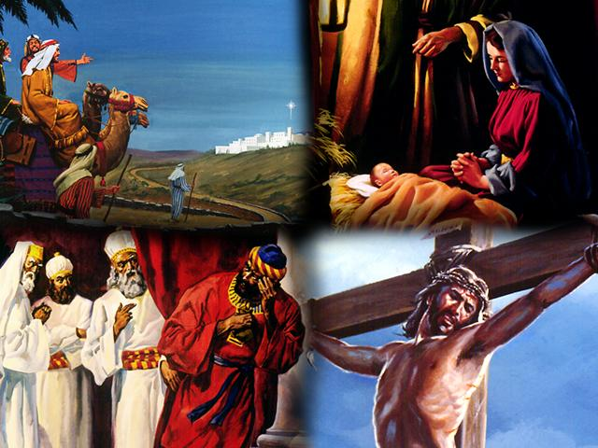

1. E. G. White. Testimonies for the Church, Vol. 1, pp. 514, 515.
2. E. G. White. Steps to Christ, p. 83.
3. SDA Bible Commentary, Vol. 6, p. 396.