**These Perilous Times**

**Vol. 15, No. 23, Dec. 7, 2023**

**“Praise God for Life”**

Psalm 139:14 states that we should: “…praise God for we are fearfully and wonderfully made, Marvelous are His works.” Genesis 1:26, 27 states that: “…we were created in the image of God.”

**What does this mean for us?**

**Obvious Signs Do Tell The Season**

**Counsel from God’s inspired messenger**

“…Life is a gift of God. The natural life is preserved moment by moment by divine power; yet it is not sustained by a direct miracle, but through the use of blessings placed within our reach. [1] “Through the agencies of nature, God is working, day by day, hour by hour, moment by moment, to keep us alive, to build up and restore us. When any part of the body sustains injury, a healing process is at once begun; nature’s agencies are set at work to restore soundness. But the power through these agencies is the power of God. All life-giving power is from Him. When one recovers from disease, it is God who restores him. Sickness, suffering, and death are the work of an antagonistic power. Satan is the destroyer; **God is the Restorer**.” [2]

“For with You is the fountain of life; in Your light we see light. Psalm 36:9

“Know that the Lord, He is God; *It is He who made us, and not we ourselves*; We are His

people and the sheep of His pasture.” Psalm 100:4

“What? know ye not that your body is the temple of the Holy Ghost which is in you, which ye have of God, *and ye are not your own*? For ye were *bought with a price*: therefore, glorify God in your body, and in your spirit *which are God’s*.” I Corinthians 6:19, 20

Jesus states very clearly in John 10:27, “My sheep hear My voice, and I know them, and they follow me.”

**Life and Good health are by God’s design not by accident-They are gifts from God!**

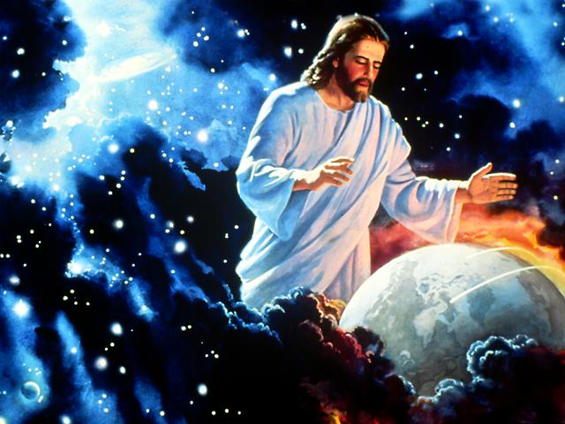

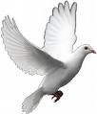

1. E. G. White. The Great Controversy, p. 69.
2. White. The Great Controversy, vi, vii.