**These Perilous Times**

**Vol. 17, No. 6, March 21, 2025**

**“When You See These Things”**

“***And now I have told you before it comes***, *that when it does come to pass, you may believe*.”

John 14:29 NKJV (Emphasis supplied)

When speaking of end-time Bible prophecies, many evangelists have quoted the afore mentioned text many times. Written in Red from the lips of our Savior. Please notice the following text also written in Red.

“Now learn a parable from the fig tree: When its branch has already become tender and puts forth leaves, you know that summer is near. So, you also, *when you see all these things* know that it is near even at the doors! Matt. 24:32, 33. NKJV

**What does this mean for?**

**Obvious Signs Do Tell The Season**

Earthquakes, severe weather, devasting storms spawning tornados, wild fires burning out of control, wars and rumors of them, political corruption and fraud, catastrophes affecting every mode of transportation, the increase of crime everywhere tells the season in which we are now living. Please read Matthew chapter 24, and II Timothy chapter 3, verse 1-5. If you have already read these chapters, please re-read again them to get a clearer understanding.

Friends, turning a blind eye to these last-day prophecies does not mean that they are not taking place. Jesus stated,” …When you see all these things…

**Counsel from God’s inspired messenger**

“There are many who do not understand the prophecies relating to these days and they must be enlightened. It is the duty of both watchmen and laymen to give the trumpet a certain sound… (see Ezekiel 33:1-9) *Let the laymen lift up their voice and give the message which is present truth for this time*. *Let us show the people where we are in prophetic history*.” [1]

“How frequently we hear of earthquakes and tornados, of destruction by fire and flood, with great loss of life and property! Apparently, these calamities are capricious outbreaks of disorganized, unregulated forces of nature, wholly beyond the control of man, but in them all God’s purpose may be read. They are among the agencies by which ***He seeks to arouse men and women to a sense of their danger***”[2] (Emphasis supplied).

Please read II Tim. 2:15 from the KJV

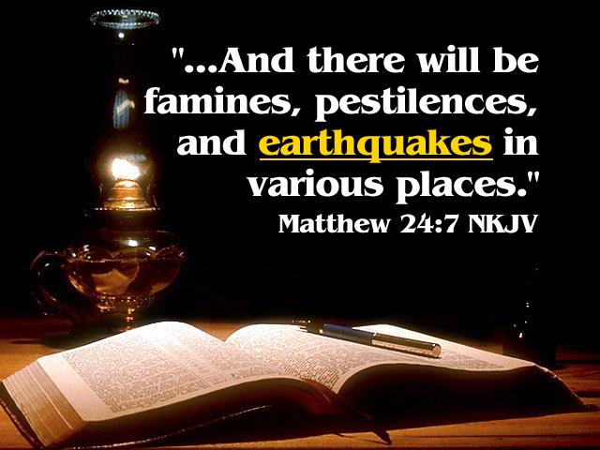

1. E. G. White. Last Day Events, p.16.
2. Ibid. p. 28.